**Current Sheet Dynamics through Magnetic Reconnection**

Y. Doke1, K. Doi1 and M. Akimitu2, and Y. Ono1

1 The University of Tokyo,

2 National Institutes for Quantum Science and Technology (QST)

e-mail (speaker): dokeyuka@g.ecc.u-tokyo.ac.jp

With the newly developed magnetic measurement system using printed circuit boards with coils densely spaced as small as 5 mm apart [1], we have studied unsteady magnetic reconnection with plasmoid, a major possible cause for the timescale gap between actual measurement and the Sweet-Parker model.

In this research, we varied the inflow speed according to the position of two coils in TS-6, the tokamak plasma merging device (Figure 1), and succeeded to examine separately how each following phenomenon has affected the reconnection acceleration.

1. Plasmoid generation and diffusion area expansion [2]
2. Anomalous resistivity [3]
3. Current sheet emission [4]

With data on the poloidal flux contour, the current sheet density, and resistivity at X points, the major results can be summarized as follows.

1. When the plasma merging distance is the farthest (700 mm), the reconnection was suddenly accelerated as soon as the long current sheet and plasmoid were created (Figure 2 (a)), but the anomalous resistivity was not observed probably because the weak inflow could not compress the current sheet so much (Figure 2 (b)).
2. Two accelerating mechanisms were observed at the middle plasma merging distance (600 mm) (Figure 3). In the former part of the reconnection, the diffusion area expansion with the generation of multiple plasmoids seems to have led to a faster reconnection. In the later part of the reconnection, anomalous resistivity of about 6 to 10 times Spitzer resistivity was detected simultaneously that the plasmoids disappeared, which can be explained clearly by the compression of the current sheet to ion Larmour radius

.

3. Two cases were observed when two plasmas were merged from the closest distance (427 mm).

Case 3.1 The strong compression caused the current sheet width to instantly become about the ion Larmour radius, resulting in anomalous resistivity, but no plasmoids were generated because plasmas could not pile up inside the current sheet (Figure 4).

Case 3.2 Although anomalous resistivity became larger as the current sheet width increased to about the ion Larmour radius, the compression was so strong that the current sheet was split and released, resulting in faster reconnection (Figure 5).

r [m]

z [m]

Jt [A/m2]

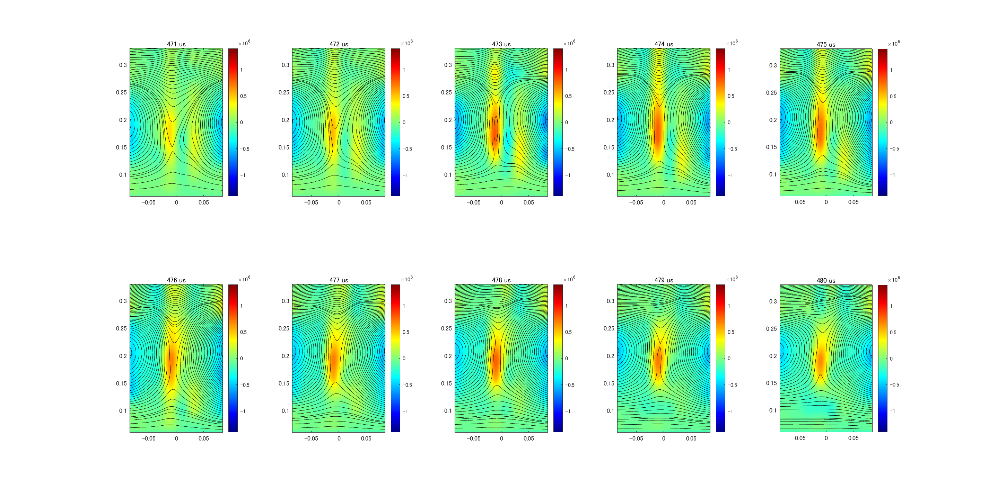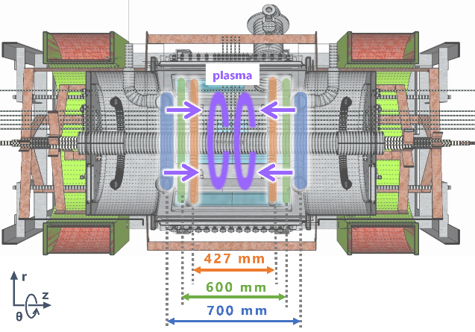

Fig.1 The position of coils in the TS-6 plasma merging device.

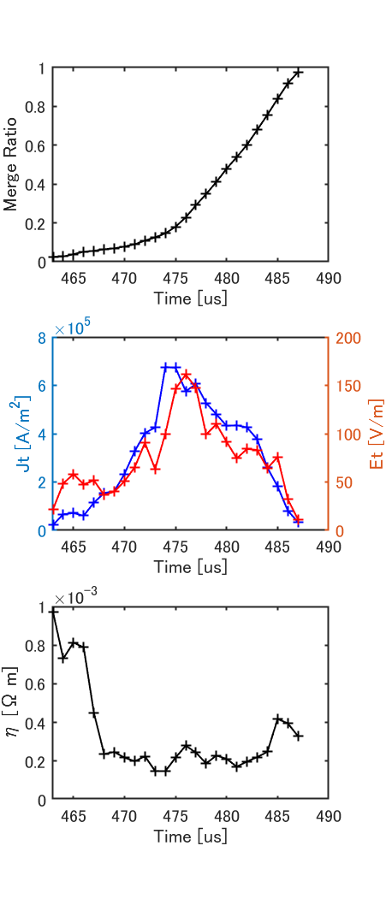

r [m]

Z [m]

Fig2. The time evolution of (a) the merging ratio of two plasmas, (b) the toroidal current density (blue) and electric density(red), and (c) the resistivity at the X point. (d) Poloidal flux contour (black) and the current density distribution (the color bar) at 473 µs when the plasmoid in the current sheet was generated.

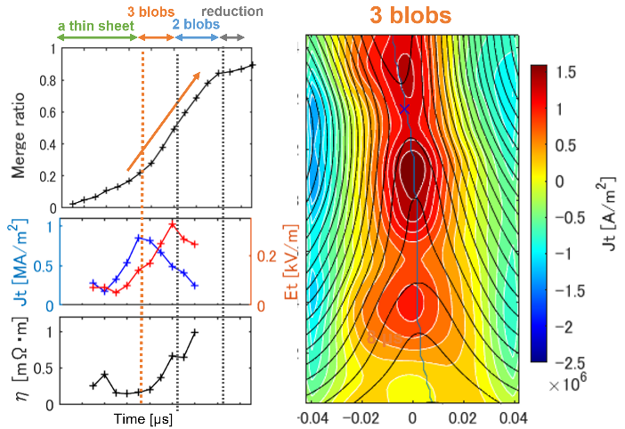

Fig3. The time evolution of (a) the merging ratio of two plasmas, (b) the toroidal current density (blue) and electric density(red), and (c) the resistivity at the X point, showing anomalous resistivity in the final stage of merging. (d) Poloidal flux contour (black) and the current density distribution (the color bar) when the three plasmoid in the current sheet was generated.

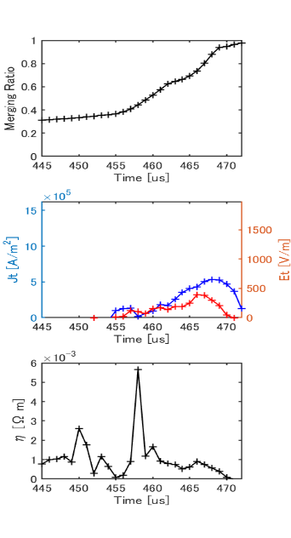パソコンの画面

Fig 4. The time evolution of (a) the merging ratio of two plasmas, (b) the toroidal current density (blue) and electric density(red), and (c) the resistivity at the X point, showing anomalous resistivity in the final stage of merging. (d) Poloidal flux contour (black) and the current density distribution (the color bar) without the current sheet emission

パソコンの画面

Fig 5. The time evolution of (a) the merging ratio of two plasmas, (b) the toroidal current density (blue) and electric density(red), and (c) the resistivity at the X point, showing anomalous resistivity in the final stage of merging. (d) Poloidal flux contour (black) and the current density distribution (the color bar) when the three plasmoid in the current sheet was ejection.

References

[1] M. Akimitsu et al., Plasma Fusion Res. 13,

1202108 (2018).

[2] M. Yamada et al., Physics of Plasmas, Vol. 13, No. 5, p. 052119, 2006.

[3] Y. Hayashi et al., IEEJ Transactions of the Institute of Electrical Engineers of Japan, Vol. 127, No. 10, pp. 660-661, 2007

[4] S. Takasao et al., The Astrophysical Journal Letters, Vol. 745, No. 1, p. L6, 2011.

With the newly developed magnetic measurement system using printed circuit boards with coils densely spaced as small as 5 mm apart [1], we have studied unsteady magnetic reconnection with plasmoid, a major possible cause for the timescale gap between actual measurement and the Sweet-Parker model.

In this research, we varied the inflow speed according to the position of two coils in TS-6, the tokamak plasma merging device (Figure 1), and succeeded to examine separately how each following phenomenon has affected the reconnection acceleration.

1. Plasmoid generation and diffusion area expansion [2]
2. Anomalous resistivity [3]
3. Current sheet emission [4]

With the two-dimensional distribution data of poloidal flux, the current sheet density and resistivity at the X point, we clarified that different acceleration mechanisms occurred according to the strongness of the current sheet compression. At the furthest plasma merging distance, the reconnection accelerated as soon as the long current sheets and plasmoids were generated. On the other hand, when two plasmas were merged from the closer position, the anomalous resistivity was detected, which could be explained by the compression of the current sheet up to the ion Larmour radius.